Strawberry Charlotte

Ingredients
1 paquet de biscuits à la cuillère  450 g de fraises fraîches  225 g de framboises surgelées  1 petite cuillère à café de gomme de guar  20 cl de crème fouettée (très froide)  Environ 1 à 400 ml de « Fage »  6 cuillères à soupe de sucre | 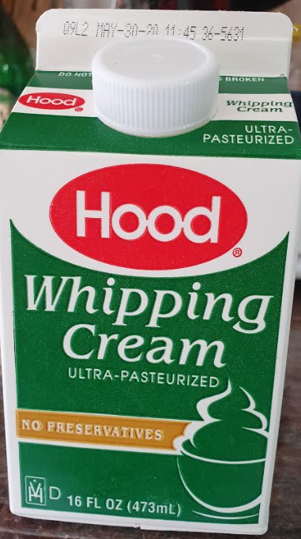
Plastic film
Square/rectangular dish (or round for the most demanding: you will have to place cookies in the spoon)

Preparation
- In a small saucepan, gently heat the frozen strawberries with 80 ml of water and 3 tablespoons of sugar. Stir from time to time until boiling. Let boil for 3 minutes.
- While raspberries heat up, place the Kenwood bowl in the refrigerator, as well as the whip accessory. The whipped cream is also there, of course.
- While the raspberries heat and the bowl cools, wash the strawberries and cut them into small pieces.
- Once the raspberries are cooked, add the Guar gum. Be careful not to add it at once: it would form a rubber shot, which is bad. Shape it gradually and stir. The gum will thicken the sauce by cooling. You can transfer the mixture to another container so that it cools faster.
N.B .: If you do not want to use gum, it is not compulsory. This is only used to prevent the cake from spreading as vomit at the time of cut. The taste will not change.
- Cover your plastic film dish. Let him go beyond to be able to fold it over the cake later. Cover the bottom and sides of the spoon cookie dish.
- Take out the whipping cream, bowl and whisk from the refrigerator and prepare a whipped cream: pour the cream into the bowl and whisk at full speed for 1 to 3 minutes (as the case may be). Add 3 tablespoons of sugar, mix again, add the Fage yogurt and mix.
Tip: Fage yogurt is only used to lighten the cake. If you don't want it, just prepare a whipped cream with 30 cl of cream.
- Raspberries must now have cooled. They should not be warmer than lukewarm. Mix the raspberries, whipped cream and strawberries.
- Pour the preparation into the dish, on the spoon cookies. Cover with a layer of cookies and close the plastic film. Lightly press the cling film to hunt air.
- Place in the refrigerator at least one night: time that the spoon cookies absorb the moisture of the mixture.

If you have too much cream/strawberry, prepare another smaller one.

